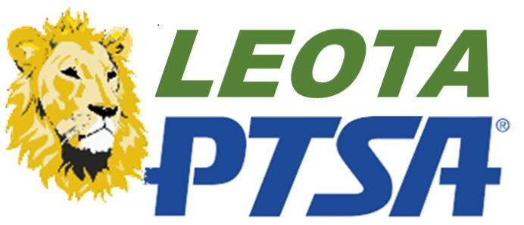
Leota PTSA- General Meeting
Zoom- Online
October 20, 2021

AGENDA
Welcome & Thank you (Tracey)
Standing rules & Last Meeting Minutes approved (Tracey & Karla)
Pave the Way Results (Carrie)
Kraken Drawing (Carrie)
Staff Appreciation (Vicki & Karla)
Math Olympiad (Niraj & Gomanthi)
Emergency Preparedness Update (Vicki H or Tracey)
Budget Approved (Angela)
Treasurer's report (Angela)
DC Trip opportunity for 7th & 8th Graders (Mrs VanAvery & Mrs Flowers)
New Business (Everyone)
Close

